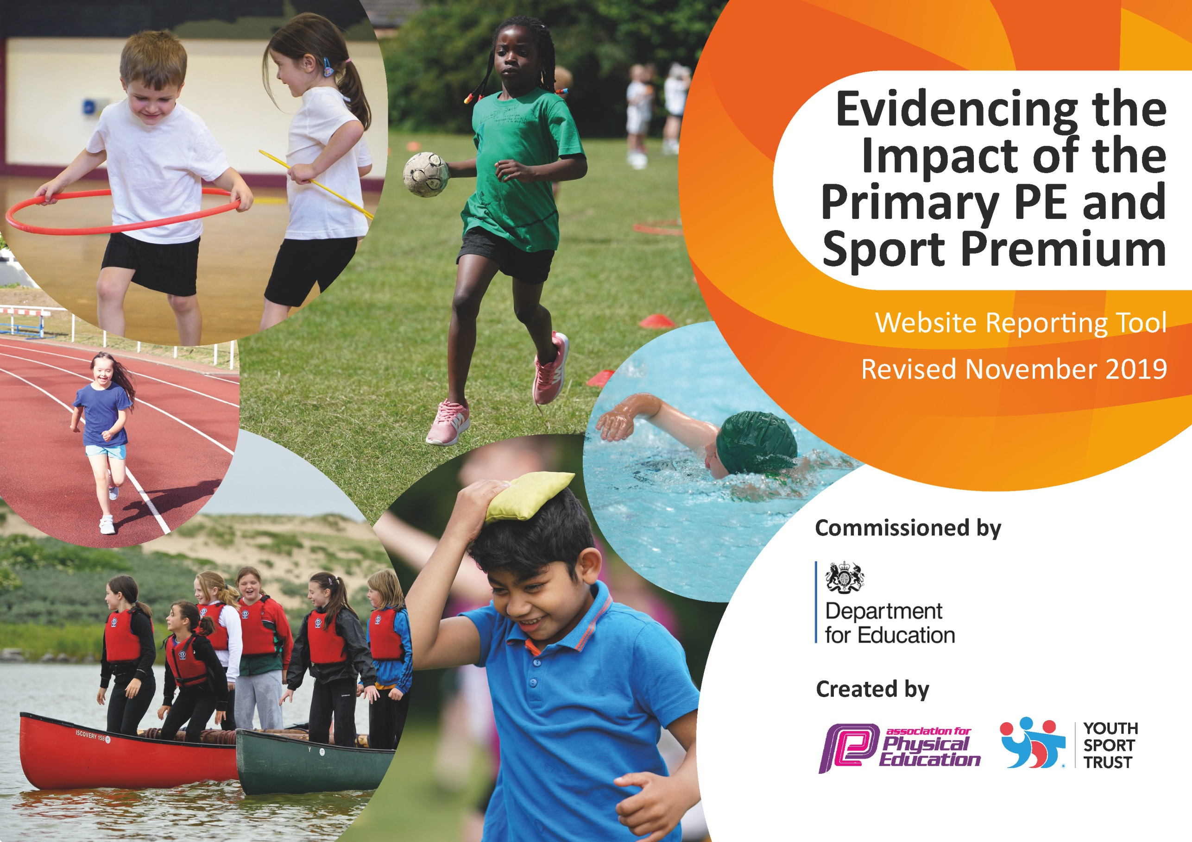
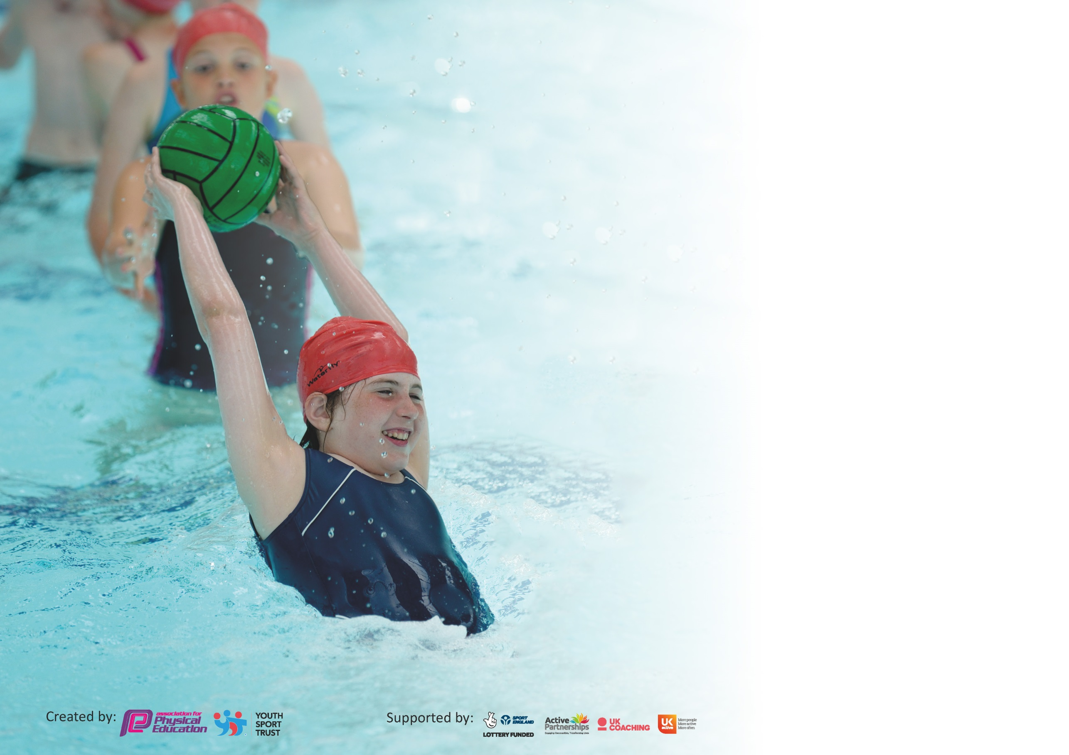

It is important that your grant is used effectively and based on school need. The Education Inspection Framework (Ofsted 2019 p64) makes clear there will be a focus on ‘whether leaders and those responsible for governors all understand their respective roles and perform these in a way that enhances the effectiveness of the school’.

Under the Quality of Education criteria (p41) inspectors consider the extent to which schools can articulate their curriculum (INTENT), construct their curriculum (IMPLEMENTATION) and demonstrate the outcomes which result (IMPACT).

To assist schools with common transferable language this template has been developed to utilise the same three headings which should make your plans easily transferable between working documents.

Schools must use the funding to make additional and sustainable improvements to the quality of Physical Education, School Sport and Physical Activity (PESSPA) they offer. This means that you should
use the Primary PE and Sport Premium to:

- Develop or add to the PESSPA activities that your school already offer
- Build capacity and capability within the school to ensure that improvements made now will benefit pupils joining the school in future years

Please visit gov.uk for the revised DfE guidance including the 5 key indicators across which schools should demonstrate an improvement. This document will help you to review your provision and to report your spend. DfE encourages schools to use this template as an effective way of meeting the reporting requirements of the Primary PE and Sport Premium.

We recommend you start by reflecting on the impact of current provision and reviewing the previous spend.

Schools are required to publish details of how they spend this funding as well as on the impact it has on pupils’ PE and sport participation and attainment by the end of the summer term or by 31st July 2020 at the latest.

We recommend regularly updating the table and publishing it on your website throughout the year. This evidences your ongoing self-evaluation of how you are using the funding to secure maximum, sustainable impact. Final copy must be posted on your website by the end of the academic year and no later than the 31st July 2020. To see an example of how to complete the table please click HERE.

Support for review and reflection - considering the 5 key indicators from DfE, what development needs are a priority for your setting and your pupils now and why? Use the space below to reflect on previous spend and key achievements and areas for development.

Key achievements to date until July 2020: | Areas for further improvement and baseline evidence of need:
Improved staff expertise and confidence leading to the quality delivery of P.E. lessons.  Pupils provided with broader experiences in P.E./sports.  Provided a diverse and wide range of extra-curricular clubs and activities.  Healthy competitive attitudes and increased participation in competitions.  All pupils engaged in regular physical activity – leading to long term positive healthy lifestyle choices.  Maintaining Silver School Games status – would have applied for Gold (Covid-19) | Continue to increase staff expertise and confidence leading to the improved quality delivery of P.E. lessons.  Continue to provide children with broader experiences in P.E./sports through external providers.  Continue to increase children’s activity levels within the school day through class based and outside activities.  Continue to increase children’s exposure to intra and inter level competitions (School Games).

Meeting national curriculum requirements for swimming and water safety.
What percentage of your current Year 6 cohort swim competently, confidently and proficiently over a distance of at least 25 metres?  N.B. Even though your pupils may swim in another year please report on their attainment on leaving  primary school at the end of the summer term 2020. | 90%
What percentage of your current Year 6 cohort use a range of strokes effectively [for example, front crawl, backstroke and breaststroke]? | 90%
What percentage of your current Year 6 cohort perform safe self-rescue in different water-based situations? | 70%
Schools can choose to use the Primary PE and Sport Premium to provide additional provision for swimming but this must be for activity over and above the national curriculum requirements. Have you used it in this way? | No

Action Plan and Budget Tracking
Capture your intended annual spend against the 5 key indicators. Clarify the success criteria and evidence of impact that you intend to measure to evaluate for pupils today and for the future.

Academic Year: 2019/20
Key indicator 1: The engagement of all pupils in regular physical activity – Chief Medical Officer guidelines recommend that primary school pupils undertake at least 30 minutes of physical activity a day in school
Intent | Implementation |  | Impact
Your school focus should be clear what you want the pupils to know and be able to do and about  what they need to learn and to  consolidate through practice: | Make sure your actions to achieve are linked to your intentions: | Funding allocated: | Evidence of impact: what do pupils now know and what can they now do? What has changed?: | Sustainability and suggested next steps:
Purchase of resources and equipment to support playground activities, competition and after school clubs. | Identify resources needed to increase the range of sports provided at lunchtimes, after school clubs and for intra school competitions as well as an appropriate trolley to easily store and move equipment. This is to ensure child led activities during lunchtimes.  Sports Day and activity events held virtually for all children to participate at home in the Spring and Summer Terms. | £550  £400 carried forward to be used to subscribe to 5 aday TV. This active programme can be used in classes throughout the day for regular exercise breaks.  Funds carried forward for Olympics event. | Playground Leaders are directly responsible for accessing and maintaining the playground trolley each day. The new resources have encouraged children to participate in sporting activities during their lunchtimes, which has increased their opportunities for physical activity during the school day. Children have a range of intra-school sporting competitions that they compete in weekly. Quality of activities benefitting pupil well-being and enjoyment.  The purchase of the equipment has increased the range of sports provided for the children and the quality of provision including after school clubs.  Resources are stored safely and effectively to ensure maximum use.  Playground leaders are also responsible for the maintenance and care of equipment which has increased the profile of PE. | As the Playground leaders become further established, increase the variety of equipment available and level of challenge.  Continue to establish playground leaders in KS1.  Continue to monitor the impact of the purchased resources and staff to ensure that they are providing a range of sporting experiences for the children and using the resources effectively.
Key indicator 2: The profile of PESSPA being raised across the school as a tool for whole school improvement
Intent | Implementation |  | Impact
Your school focus should be clear what you want the pupils to know and be able to do and about  what they need to learn and to  consolidate through practice: | Make sure your actions to achieve are linked to your intentions: | Funding allocated: | Evidence of impact: what do pupils now know and what can they now do? What has changed?: | Sustainability and suggested next steps:
New, complete Sports kits to engage and raise the profile of competitions.  Resources for competitions purchased.  Increase engagement in PE from staff, enforcing appropriate clothing for teaching and setting an example to pupils.  Increase intra school competition. | Purchase of additional water bottles for competitions.  Purchase of new competition kits and hoodies.  Purchase of staff jumpers to raise the profile of PE.  All kits embroided – numbers and school logo.  Trophies for intra school competitions ‘class wars’. | £550  £330  Funds carried forward to develop social distancing intra school competition. | Children get a full school kit to wear during competitions and they are responsible for this. Children are proud to represent their school. All kits are number to ensure they are well looked after.  Staff are more confident to wear appropriate PE clothing and now have their own top. This has raised the profile of PE across the school.  Children enjoy competing for the trophy each half term. | Ensure all kits are returned to school with ‘kit list’ form completed.  Staff register of who has staff kits to be maintained and new tops to be ordered as and when appropriate.

Key indicator 3: Increased confidence, knowledge and skills of all staff in teaching PE and sport
Intent | Implementation |  | Impact
Your school focus should be clear | Make sure your actions to | Funding | Evidence of impact: what do | Sustainability and suggested
what you want the pupils to know | achieve are linked to your | allocated: | pupils now know and what | next steps:
and be able to do and about | intentions: |  | can they now do? What has
what they need to learn and to |  |  | changed?:
consolidate through practice:
Confident delivery of high quality P.E. lessons ensuring pupils develop their skills in a range of sporting activities.  Increased physical activity and parental engagement.  Families making healthier lifestyle choices for their children. | Contract with accredited external sports provider –  City in The Community [MCFC] Provide a coach to support staff CPD and after school activities. Also providing enrichment activities such as football for EYFS, social action project and healthy cooking sessions for pupils and parents.  City Play programme for EYFS.  Beth Tweddle Gymnastics – external coach delivering gymnastics alongside class teacher.  Promoting PE in school using social media to engage parents. | £6000  £950  £4000  Funds carried forward for PE Subject Lead training cancelled due to Covid. | Teachers’ ability and confidence in the delivery of PE has improved due to their enhanced subject knowledge. This has improved the quality of the PE lessons for children across the school. Lesson observations carried out by PE lead.  Targeted support provided for NQTs/RQTs.  High Quality CPD provided for staff to support quality teaching.  Impact evident in lessons & skill acquisition by children.  Improved outcomes for pupils evidenced through end of topic assessments for all age-groups.  Pupils and parents are making healthier lifestyle choices with the food choices they are giving their children for lunches/snacks. This is leading to children living a healthier lifestyle. Use of City Cooks Programme to support this. | Continue to develop teacher confidence in different aspects of PE as a result of courses attended.  Continue to increase engagement among pupils and parents in the next year.
Key indicator 4: Broader experience of a range of sports and activities offered to all pupils
Intent | Implementation |  | Impact
Your school focus should be clear | Make sure your actions to | Funding | Evidence of impact: what do | Sustainability and suggested
what you want the pupils to know | achieve are linked to your | allocated: | pupils now know and what | next steps:
and be able to do and about | intentions: |  | can they now do? What has
what they need to learn and to |  |  | changed?:
consolidate through practice:
Introduce children to broader experiences in sport and encourage commitment and longevity in healthy lifestyle choices.  External inspirational visitors to school.  Enhancement of PE schemes to ensure high quality lesson planning. | Specialist coaches employed to deliver PE sessions each week and after school. Different after school clubs run each half term to increase engagement and provide variety of sports.  Freddy Fit coaching whole school.  Dance Notes Schemes of work.  Events and competitions cancelled due to Covid 19 including Gaelic Football, American Football, Rugby, Swimming, Multi-skills. (See Manchester PE Events Calendar) | See above cost for coaches  £400  £60  £455  Funds carried forward to subscribe to the PE Hub to broaden experiences offered to children and enhance current planning resources (including social distancing planning).  Funds carried forward to provide outsourced afterschool clubs each day following Covid-19 social distancing and bubble guidelines. | Requisition/Invoice, school timetable and after school club register.  Children throughout the school have developed both specific and transferable skills across a range of topics.  Children are making healthier lifestyle choices. Children have increased self-discipline and commitment.  Children have had increased opportunities for competition through their broader experiences.  Children have developed their understanding and practice of the PLPS Values of be ambitions, be inspiring, be fair, be active, be connected.  PE lesson is maximised due to all resources being immediately accessible.  This has ensured the school maintains Silver School Games status. School would have been applying for Gold this year if the award had not been suspended. | To continue the delivery of high standard broader experience sessions.  Develop more external links to encourage children’s engagement beyond primary school. Contact has been made with local Rugby club in walking distance.  Continue and enhance the use of Dance Notes Scheme across the school.

Key indicator 5: Increased participation in competitive sport
Intent | Implementation |  | Impact
Your school focus should be clear | Make sure your actions to | Funding | Evidence of impact: what do | Sustainability and suggested
what you want the pupils to know | achieve are linked to your | allocated: | pupils now know and what | next steps:
and be able to do and about | intentions: |  | can they now do? What has
what they need to learn and to |  |  | changed?:
consolidate through practice:
Children to participate in regular competitions across Manchester and with local schools. | Member of Manchester PE Association.  Children attended a wide range of competitions across KS1 and KS2 giving children an opportunity to regularly compete against children from other schools – See Manchester PE calendar and St Matthew’s Partnership half-termly competitions.  Half – termly intra school competitions ran by the School Sports Council. Giving children the opportunity to compete against other classes.  Scheduled Whole School Event to celebrate the Olympics in Summer Term cancelled. | £900 | Participation in Manchester PE Association competitions.  Children have received a number of opportunities to compete in their desired sporting activity as well as sports they are unfamiliar with. This has allowed them to develop their sporting skills and take part in more events and competitions. These have been celebrated in school ‘Celebration Assemblies’ to inspire other children.  This has ensured the school maintains Silver School Games status. School would have been applying for Gold this year if the award had not been suspended. | Continue to increase the range of activities and the groups of children attending, including SEN – inclusion event schedule and postponed due to Covid.
Transport to and from events. | Hiring minibus and transportation to sporting events. Rolling Programme of transportation booked in for key events & sporting enrichment to allow children to access events around the city. Coordinated by P.E. Lead & Administrative Assistant. | £1,100 Travel  Funds carried forward to ensure transport for next academic year. | Minibus requisitions and invoices.  Children have participated in a range of sporting activities during and outside of school time through the Manchester P.E. Association, local Football Clubs and St Matthew’s Partnership including:  Football, Multi-Sports, Swimming-Galas, Athletics, Cross-Country, Basketball and Netball.  (Scheduled events from March cancelled due to Covid-19).  This has been across KS1 and KS2.  Participation has been in City-Wide and Inter-School Sports events.  Competitions increased.  Children gained further experience of inter-school competition & the school has maintained the School Games Silver Award with the intent of applying for Gold status.  Children have experienced a range of competitive sports, in a range of venues. | To continue the rolling programme of transportation booked in for key events & sporting enrichment.

Events didn’t take place due to school closure. Remaining sports premium money to be carried forward to next academic year to go towards equipment
and resources for class bubbles due to Covid 19 and social distancing requirements.

Signed off by
Head Teacher:
Date:
Subject Leader: | K.McCreavy
Date:
Governor:
Date:

