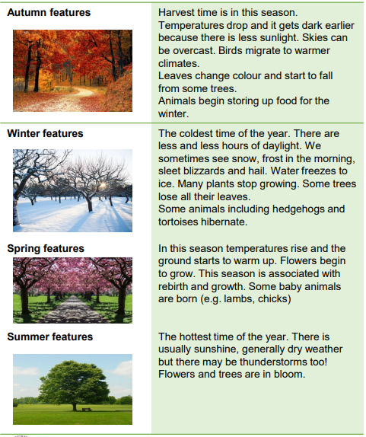

Days are longer in the summer and shorter in winter

Weather changes through the year, getting hotter in the summer and colder in the winter.

Objectives

-observe changes across the four seasons

-observe and describe weather associated with the seasons and how day length varies

|  |  |
| --- | --- |
| Vocabulary | |
| Autumn | The time of year between September and November. Many leaves fall off the trees. |
| Spring | The time of year between March and May. This is usually signs of new growth in spring. |
| Summer | The hottest season in the UK. It happens between June and August. |
| Winter | The coldest season in the UK. Winter occurs between December and February. |
| Weather | Weather is what the sky and air outside are like, such as cold and cloudy. |
| Weather symbol | These are signs used to help us understand more about our daily weather. |
| Deciduous | Deciduous trees are trees that shed their leaves once a year, usually during the season of autumn. |
| Evergreen | Evergreen trees are trees that stays green throughout the year. |

Sticky knowledge