Vocabulary
Matter | Any solid, liquid or gas that exists in the universe
Paper | Paper is a material made from wood.
Natural | Existing in or created from nature. Not made or caused by humankind.
Man-made | Made or caused by humans.
Suitable | Right or appropriate for a purpose or situation.
Rigid | Unable to bend or be forced out of shape.
Reflect | A reflective surface is one that can bounce back light.
Squash | Squashing is pushing things closely together.
Twist | To twist something you move one part clockwise and the other part anticlockwise.
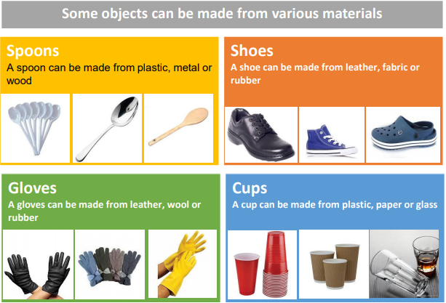
Objectives
-compare and group materials together, according to whether they are solids, liquids or gases
-observe that some materials change state when they are heated or cooled, and measure or research the temperature at which this happens in degrees Celsius (°C)
-identify the part played by evaporation and condensation in the water cycle and associate the rate of evaporation with temperature

Which properties best describe a brick?
Rigid strong flexible rough shiny
Sticky knowledge
Wood is used to make buildings and furniture and for making fires.
Most of the paper and cardboard we use comes from trees.
Glass is a hard transparent material that can be made in many shapes.
Glass is usually transparent which means you can see through it. Glass can also come in different colours.
Plastics are used to make many of the things we use in everyday life. Plastic can be used to make toys, bicycle helmets, mobile phones, window frames and many other common items.
When we apply forces to objects, it can change their shape.
Different materials have different properties such as:
- Steel is strong
- Rock is hard
- Rubber is flexible
- Rock is rigid
- Polystyrene is light

