Vocabulary
Offspring | The child of a human or animals.
Life cycle | A series of changes that an animal or plants passes through from the beginning of its life until death.
Diet | The food and water that an animal needs.
Exercise | A physical activity to keep your body fit.
Hygiene | How clean something is. Taking care of our body by being clean and making sure we don’t smell.
Reproduce | When living things make a new living thing of the same kind.
Sticky knowledge
Plants and animals produce offspring that grow into adults.
Animals, including humans, need food, water and air to survive.
The basic food groups are: fruit and vegetables, carbohydrates, protein, dairy, fat and sugary foods.
More than half of our diet should be made up of carbohydrates, fruit and vegetables.
Fats and sugary foods should be eaten rarely and in small amounts.
People need to exercise often to help their body stay strong and fit.
Keeping clean, including washing and brushing teeth, is an important part of staying healthy.
Some animals are carnivores (meat eaters), some are herbivores (eat plants) and some are omnivores (eat both).

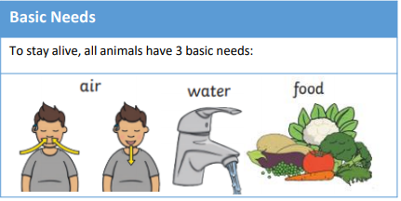
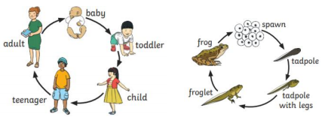
Objectives
-notice that animals, including humans, have offspring which grow into adults
-find out about and describe the basic needs of animals, including humans, for survival (water, food and air)
-describe the importance for humans of exercise, eating the right amounts of different types of food, and hygiene.
Did you know?
