Vocabulary
Igneous rocks | Rocks formed from molten rock.
Sedimentary rocks | Rocks formed under the sea.
Metamorphic rocks | Rocks formed when other rocks are affected by great temperatures and pressures.
Permeable | Having pores or openings that let liquids or gases pass through.
Impermeable | Not allowing something – such as a liquid – to pass through.
Fossil | The preserved remains or traces of a dead organism
Soil | Soil consists of a mix of organic material (decayed plants and animals) and broken bits of rocks and minerals.
Organic matter | Organic matter is matter that has come from a recently living organism. It is able to decay.
Sticky knowledge
Rocks are made up of grains that are packed together.There are three types of rocks: igneous, sedimentary and metamorphic.
Granite and basalt are types of igneous rocks. Igneous rocks form from molten rock below the Earth’s crust.
Limestone and sandstone are types of sedimentary rock which form when small, weathered fragments of rock or shell settle and stick together, often in layers.
Marble and slate are types of metamorphic rock which form when rocks in the Earth’s crust get squashed and heated in processes such as when tectonic plates press against each either.
Fossils are the preserved remains or traces of a dead organism. They provide evidence for how living things and the environment have changed over time.
Soil is a mixture of tiny particles of rock, dead plants and animals, air and water. Different soils have different properties depending on their composition.

Objectives
-identify how sounds are made, associating some of them with something vibrating
-recognise that vibrations from sounds travel through a medium to the ear
-find patterns between the pitch of a sound and features of the object that produced it
-find patterns between the volume of a sound and the strength of the vibrations that produced it
-recognise that sounds get fainter as the distance from the sound source increases
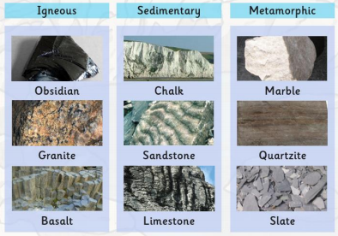
Slate does not let water soak through it. Is this an example of a permeable or impermeable rock?

