Vocabulary
Stamen | The male part of a flower containing pollen.
Carpel | The female part of a flower containing pollen.
Fertilisation | When pollen and an egg join together to make a seed.
Seed dispersal | The movement or transport of seeds away from the parent plant.
Pollen | A powdery yellow substance from the male part of a flower.
Pollination | The act of transferring pollen grains from the male anther of a flower to the female stigma.
Nectar | A sweet fluid in flowers that attracts insects.
Anther | The stamen has a pollen producing structure at the end which is called the anther.
Stigma | Usually sticky and receives pollen.
Sticky knowledge
The roots collect water and minerals from the soil and hold the plant firmly in the ground.
The stem holds up the leaves so that they can gather light to make food and holds up the flowers so that they can receive pollen and disperse their fruits.
The stem transports water and minerals from the roots to the other parts of the plant.
Leaves make food by trapping light and using its energy to turn carbon dioxide and water into carbohydrates.
The function of a flower is reproduction, where flowers exchange pollen – made by an anther – in a process called fertilisation.
After fertilisation, a structure in the flower’s ovary called an ovule becomes a seed.
Seed dispersal is a method of moving the seeds away from the parent plant so that the seeds have the best chance of survival.

Objectives
-identify and describe the functions of different parts of flowering plants: roots, stem/trunk, leaves and flowers
-explore the requirements of plants for life and growth (air, light, water, nutrients from soil, and room to grow) and how they vary from plant to plant
-investigate the way in which water is transported within plants
-explore the part that flowers play in the life cycle of flowering plants, including pollination, seed formation and seed dispersal

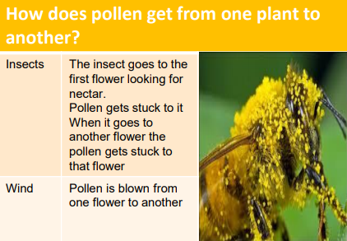
How do new seeds get to the soil to grow?

