Vocabulary
Digestion | Digestion is the way the body breaks down the food we eat into smaller parts that can be used to give the body energy.
Molars | Back teeth for crushing and grinding food.
Incisors | Front teeth for snipping and cutting food.
Canines | Long pointed teeth for grabbing food.
Predator | Animals which eat other animals.
Prey | Animals that are eaten by other animals.
Producer | Food chains start with a producer (usually a green plant or algae).
Consumer | A living thing which gets their food by eating plants or other animals.
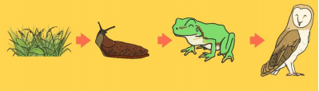
Can you match the tooth to the correct name?
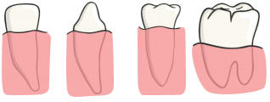

Molar Incisor Canine Premolar

Sticky knowledge
Food passes through the body with the nutrients being extracted and the waste products excreted, and that this process is called digestion.
The process of digestion involves breaking down food into simpler building blocks that can be absorbed by the body.
The process of digestion begins with food being chewed in the mouth by the teeth and saliva is added.
All energy for a food chain initially comes from the Sun which is absorbed and turned into energy by plants which are called producers.
An animal that is eaten by another is called prey and an animal that eats other animals is called a predator.
The arrows in a food chain show the direction that energy is travelling through a habitat.

Objectives
-describe the simple functions of the basic parts of the digestive system in humans
-identify the different types of teeth in humans and their simple functions
-construct and interpret a variety of food chains, identifying producers, predators and prey
Human teeth
Teeth grow in babies when they are about 6 months old. 20 teeth grow by the time you are about 2.5 years old. From about the age of 6, you start to lose teeth until about the age of 12. These teeth are replaced by 32 permanent teeth.

