Vocabulary
Circuit | A complete path that an electric current can flow around.
Conductivity | Electrical conductivity is the measure of the amount of electrical current a material can carry or its ability to carry a current.
Circuit diagram | A visual representation of an electrical circuit using symbols to represent the electrical components.
Series circuit | A series circuit is one that has more than one resistor, but only one path through which the electricity flows.
Voltage | An electrical force that makes electricity move through a wire which is measured in volts (V).
Current | A flow of electricity measured in amps.
Parallel circuit | A parallel circuit is a closed circuit where the current divides into two or more paths.
Sticky knowledge
In order for electricity to flow, a circuit needs 3 things: 1. A source of electricity 2. No gaps in the circuit 3. Conductors.
A series circuit has only one route for the current to take. If more bulbs or buzzers are added, the power has to be shared and so they will be dimmer or quieter. If just one part of this series circuit breaks, the circuit is broken and the flow of current stops.
Voltage is a measure of the power of a cell to produce electricity; it is a measure of the ‘push’ of electric current, not the size of the electric current.
If one bulb blows in a parallel circuit, there will still be a complete circuit for the other bulb so it will continue to shine.
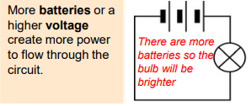
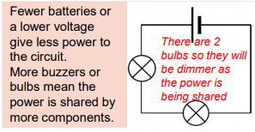

Objectives
-associate the brightness of a lamp or the volume of a buzzer with the number and voltage of cells used in the circuit
-compare and give reasons for variations in how components function, including the brightness of bulbs, the loudness of buzzers and the on/off position of switches
-use recognised symbols when representing a simple circuit in a diagram

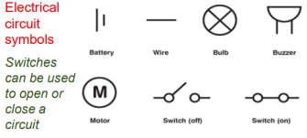
Can you label the electrical components and identify the type of circuit?
