[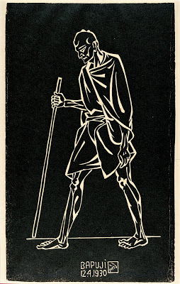](http://2.bp.blogspot.com/_ESC4bygtp2M/SJMWA0a9KWI/AAAAAAAAEMM/3mVPsqvdc84/s1600-h/Nandalal+2.DandiMarch.jpg)

Vocabulary:

Line, form, draw,

Sketch, form

1. Research about Ghandi,

Pictures and notes in sketchpads.

1. Transcriptions of famous picture .
2. Opposites white chalk on black paper and charcoal on white – to be displayed next to each other.

**Key stage 2** Pupils should be taught to develop their techniques, including their control and their use of materials, with creativity, experimentation and an increasing awareness of different kinds of art, craft and design. Pupils should be taught:

* to improve their mastery of art and design techniques, including drawing, painting and sculpture with a range of materials for example, pencil, charcoal, paint, clay
* Introduce the children to the painting
* Research on Gandhi- why is he so important globally?
* Use Ipads
* Look at the picture (paths) how does it make you feel? What has Gandhi done to change the world?

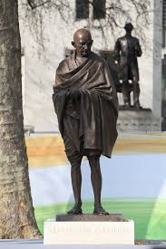

[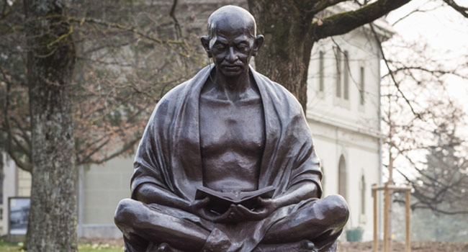](https://www.google.co.uk/url?sa=i&rct=j&q=&esrc=s&source=images&cd=&cad=rja&uact=8&ved=2ahUKEwirxJXDoO_aAhWGORQKHYVaDi0QjRx6BAgBEAU&url=https://www.indiatoday.in/education-today/gk-current-affairs/story/gandhi-outside-india-952497-2016-01-29&psig=AOvVaw2I1mNkOuxVHquNUS7bZHpH&ust=1525633070767216)

Use clay to make a sculpture model of Ghandi.

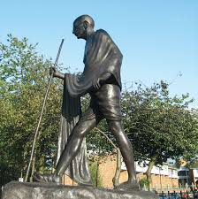

2. Research Indian architecture and sculptures relating to Ghandi.

**South east asia project – years 5 and 6 - ghandi**

Dandi March (Bapuji), 1930. Linocut on paper, 13 3/4 x 8 7/8 inches. National Gallery of Modern Art, New Delhi.