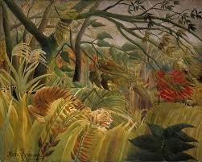

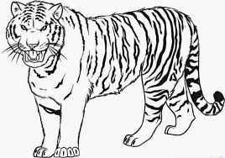

[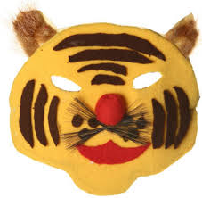](https://www.google.co.uk/url?sa=i&source=images&cd=&cad=rja&uact=8&ved=2ahUKEwjDs5fNsIbbAhUKKuwKHUwyBbsQjRx6BAgBEAU&url=https://www.activityvillage.co.uk/tiger-mask-craft&psig=AOvVaw1-MrAVvIvXrSBqGf_-vnVq&ust=1526427708672256)

[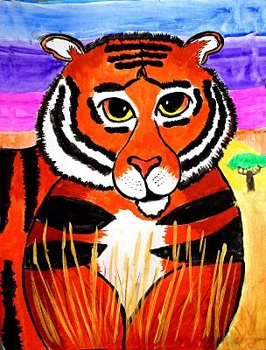](https://www.google.co.uk/url?sa=i&source=images&cd=&cad=rja&uact=8&ved=2ahUKEwiFlKzEtIbbAhWMWRQKHeAAAucQjRx6BAgBEAU&url=https://www.pinterest.com/annemccarth0196/henri-rousseau-art/&psig=AOvVaw1blauBxg2f-qMWsn4zvpxS&ust=1526428730911354)

**Vocabulary**

Line, texture, colour,

Sketch, draw, paint

[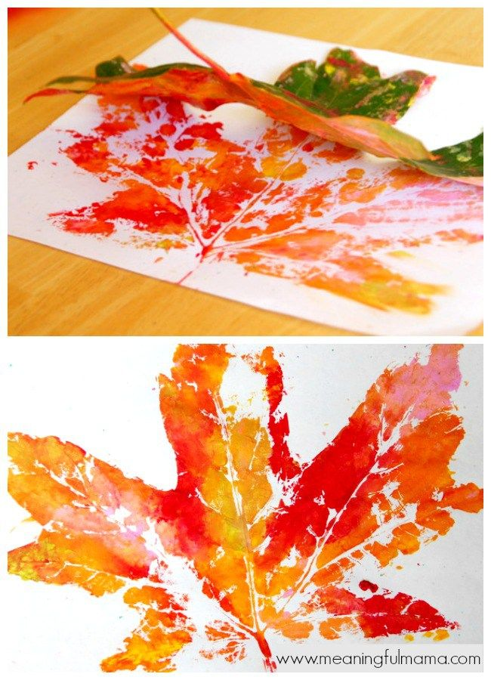](https://www.google.co.uk/url?sa=i&source=images&cd=&cad=rja&uact=8&ved=2ahUKEwiMtL2CsYbbAhUF7RQKHSKwDSsQjRx6BAgBEAU&url=https://www.pinterest.co.uk/pin/1618549846800890/&psig=AOvVaw2Ax5Zny7pNw9ayal-_3paM&ust=1526427849435022)

Key stage 2 Pupils should be taught to develop their techniques, including their control and their use of materials, with creativity, experimentation and an increasing awareness of different kinds of art, craft and design. Pupils should be taught:

• to improve their mastery of art and design techniques, including drawing, painting and sculpture with a range of materials for example, pencil, charcoal, paint, clay

* Focus on painting
* Sketch the background looking at pencil techniques and colours
* Leaf printing- take the children outside to explore the grounds, pick a leaf and use it to print Tiger art
* Recap on painting
* Range of tiger pictures
* Sketch and collage with white, red, black and orange Tiger masks
* Recap over different shapes in a tigers face- sketch to practice
* Tiger masks- create a tiger mask of using paint and sketching
* Link to English: Tyger burning bright William Blake

Key Stage 2 – Years 3 and 4

**South East Asia Project – Artist Henry Roussau – “Tiger”**