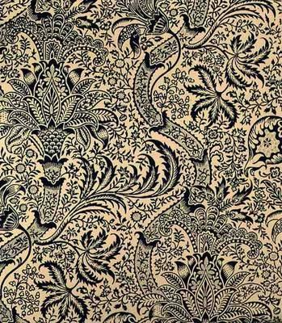

Use chalk to create a symmetrical Rangoli pattern using the Paisley symbol.

Use symmetrical feature of I pad to make a pattern.

**South East Asian Art and Design Project**

**Key Stage 1 – Year 1 and 2 – Pattern - Artist – William Morris**

The Mango and the Indian Paisley design, Mehndi and Rangoli patterns

(William Morris and Co. Indian Wallpaper) Paisley pattern from Scotland based on Indian design

Vocabulary: pattern, shape, line, texture, observation, symmetry, pen, ink, chalk, collage, applique.

Observational mango drawings.

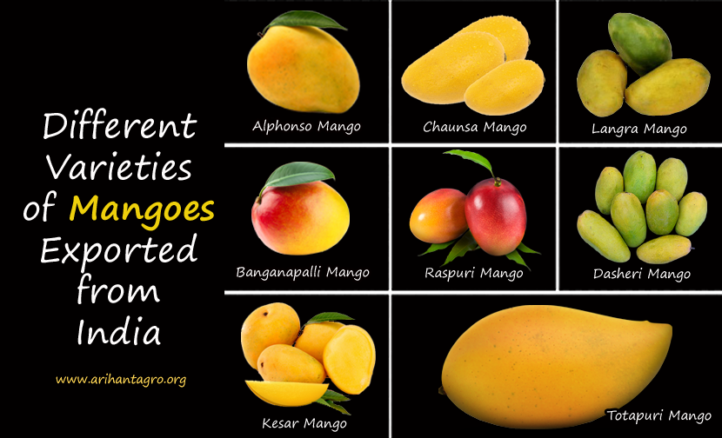

**Programme of Study -** Use a range of materials creatively to design and make products -to use drawing, painting to …develop and share their ideas, experiences and imagination to develop a wide range of art and design techniques in using colour, pattern, texture, line, shape, form and space about the work of a range of artists, craft makers and designers, describing the differences and similarities between different practices and disciplines, and making links to their own work

Investigate the Designs of William Morris and other Paisley material patterns which are seen in Mehndi and Rangoli patterns. Draw Mehndi hand patterns with a paisley design on brown paper with red or black felt tipped pens.

[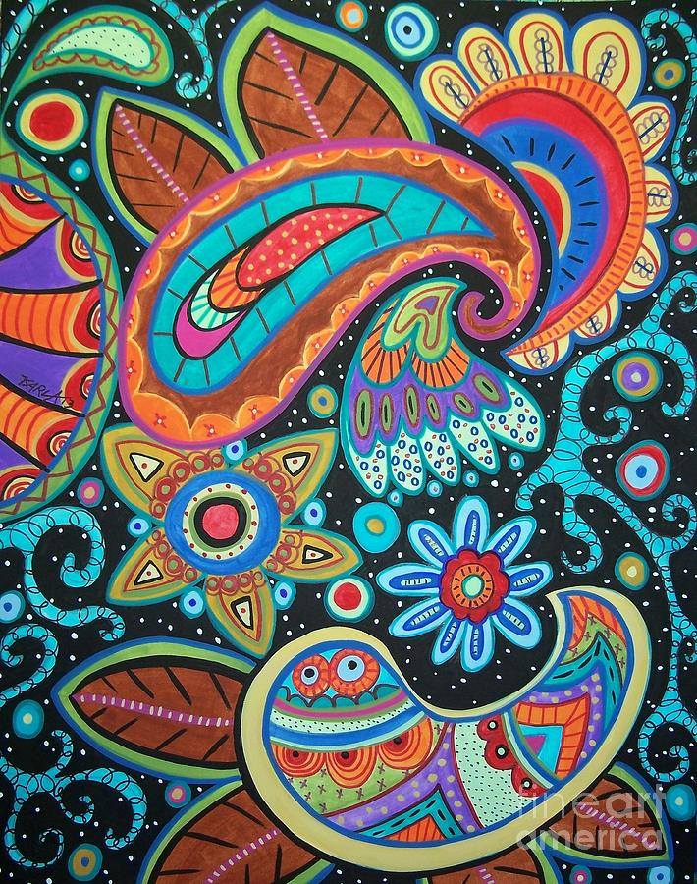](https://fineartamerica.com/featured/abstract-paisley-karla-gerard.html)

**Final piece**

Felt paisley shapes on top of each other with sequin detail.

[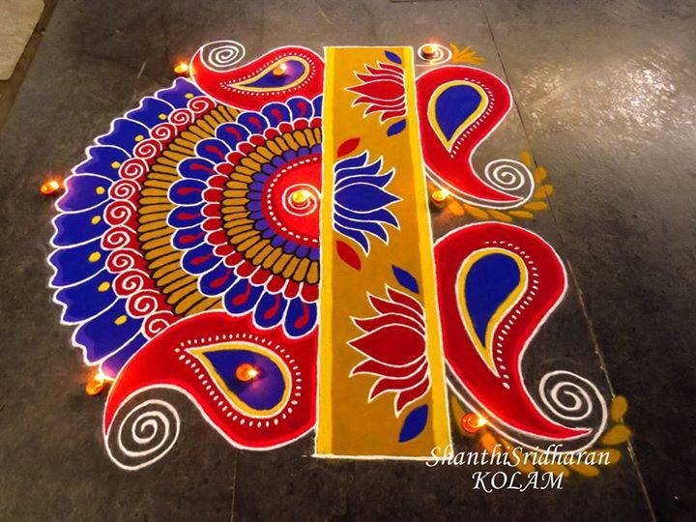](https://www.google.co.uk/url?sa=i&rct=j&q=&esrc=s&source=images&cd=&cad=rja&uact=8&ved=2ahUKEwicjPKW6vbaAhXqKcAKHZqXA4IQjRx6BAgBEAU&url=https://www.pinterest.co.uk/pin/112167846948671075/&psig=AOvVaw3CFjFZ2OrxZm5I22gjF1tJ&ust=1525893248024729)

[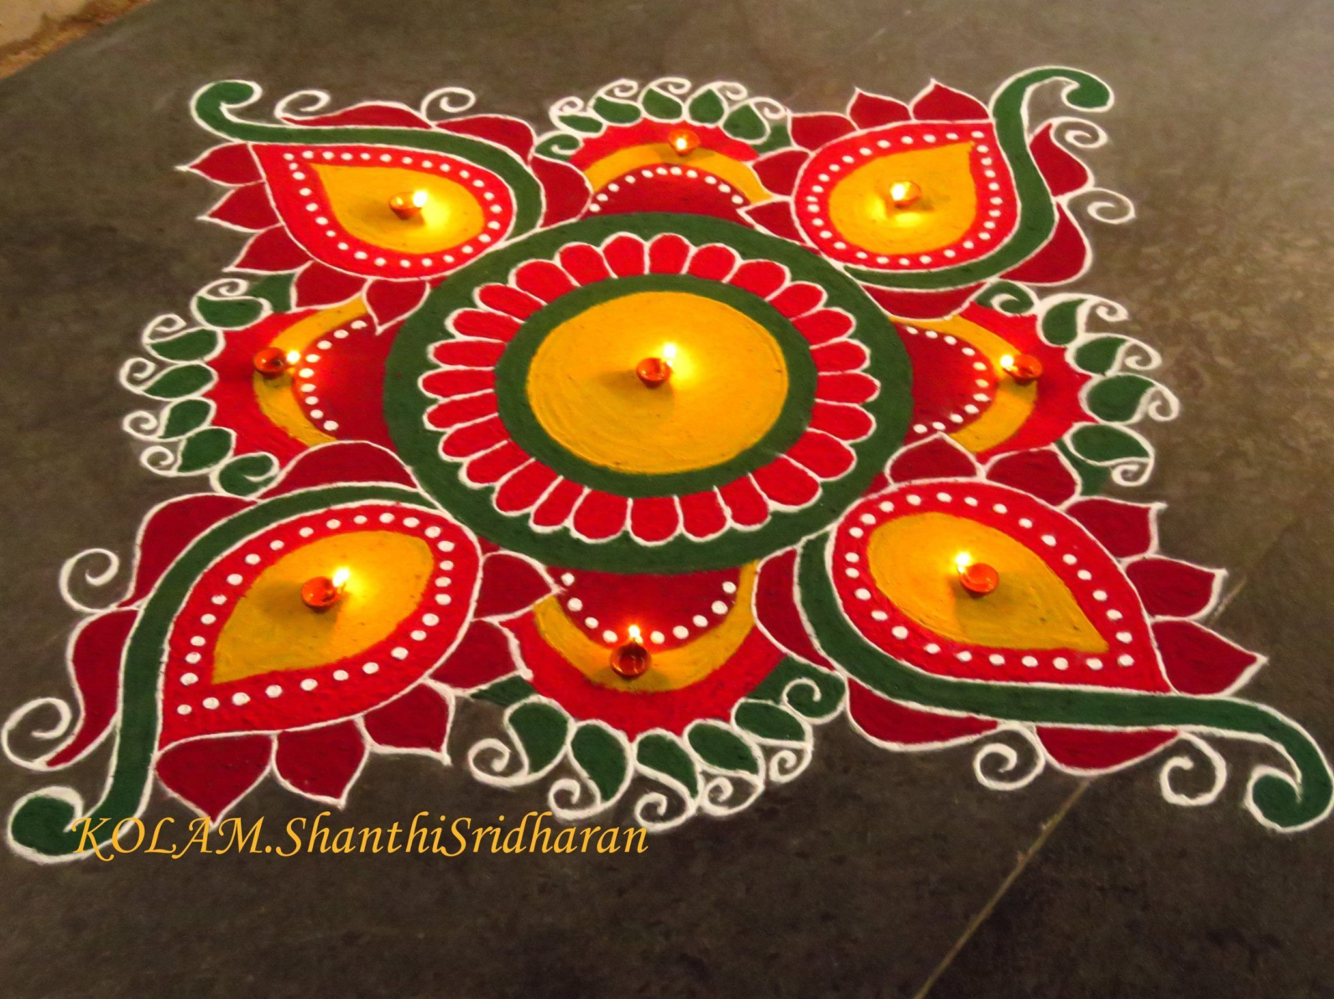](https://www.google.co.uk/url?sa=i&rct=j&q=&esrc=s&source=images&cd=&cad=rja&uact=8&ved=2ahUKEwio3N_46fbaAhVMC8AKHYcEBM4QjRx6BAgBEAU&url=https://www.pinterest.com/pin/112167846947407882/&psig=AOvVaw3CFjFZ2OrxZm5I22gjF1tJ&ust=1525893248024729)

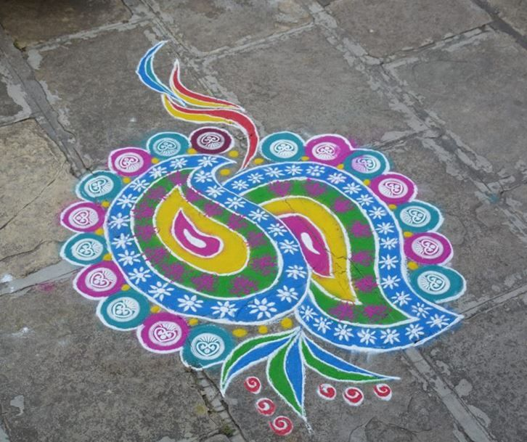

[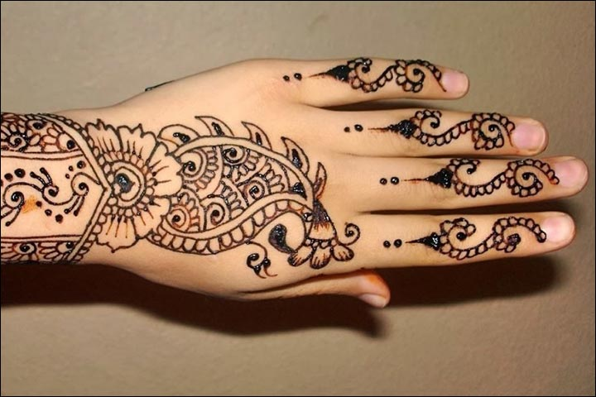](https://www.google.co.uk/url?sa=i&rct=j&q=&esrc=s&source=images&cd=&cad=rja&uact=8&ved=2ahUKEwiYi7e_5_baAhUHBsAKHXQLAfcQjRx6BAgBEAU&url=http://www.wedandbeyond.com/blog/30-trendy-punjabi-mehndi-designs/&psig=AOvVaw2P6Lm9PebWfCfzR-Go87Fv&ust=1525892713751153)

[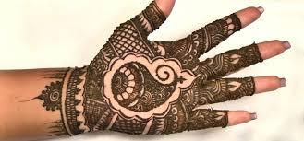](https://www.google.co.uk/url?sa=i&rct=j&q=&esrc=s&source=images&cd=&cad=rja&uact=8&ved=2ahUKEwiI44D35_baAhXMe8AKHYbxAzIQjRx6BAgBEAU&url=https://beautyhealthtips.in/henna-inspiration-palm-designs-with-photos/&psig=AOvVaw2P6Lm9PebWfCfzR-Go87Fv&ust=1525892713751153)

