3I’s
Intent

Learning in DT at St Margaret Mary’s We try to follow Jesus in everything we do.

Why is DT important at St Margaret Mary’s?

Our DT curriculum has been specifically tailored to meet the needs of our school community. It is designed to be broad and balanced, providing all pupils with the opportunity to be curious and wise in their learning and knowledge. We enable children to be attentive and discerning in order to make sense of the world around them and give purpose as to why we learn about and from DT. This will help them become faith-filled and hopeful in their abilities to change and transform our society.
During their time at St Margaret Mary’s RC Primary School children are taught DT through an integrated creative curriculum in all phases. This means that they will learn the skills, knowledge and understanding set out in the National Curriculum through an engaging and exciting approach.
During the Early Years Foundation Stage (EYFS), DT is taught through the areas of learning known as ‘Expressive Arts and Design’ and ‘Fine Motor Skills’ as set out in our Early Years Progress Model, in which the children are taught skills and knowledge such as painting, drawing, collage and sculpture.
Our topics are spilt on a two-year rolling programme due to mixed aged year groups. Over course of their journey in primary school, children develop their knowledge & understanding and skills in Design and Technology, taking into consideration prior knowledge and world/local events.
At St Margaret Mary’s we believe that Design and Technology helps to incorporate creativity and imagination, giving pupils the opportunity to design and make products that solve real and relevant problems within a variety of contexts, considering their own and others’ needs, wants and values.
We recognise that Design and Technology can require pupils to draw on disciplines such as Mathematics, Science, Computing and Art.
We aim to build high levels of competence in the subject specific skills of:
- Design
- Textiles

- Materials
- Construction
- Evaluation
- Cooking and nutrition

Implementation
At St Margaret Mary’s, Design and Technology is taught through the framework of the 2014 National curriculum. The principles and content of its requirements have been carefully placed at the heart of the school’s programmes of study in Design and Technology.
We follow a curriculum overview based on a two yearly cycle of topics using the ‘Kapow’ Design and Technology resources. Teachers within each phase from EYFS, Key Stage 1, Lower Key stage 2, and Upper Key stage 2 work together to plan a sequence of lessons often linked with their topic. These plans are closely linked to the school’s Age Related Expectations (AREs) in Design and Technology for each year group, which allows a consistent application of the curriculum throughout the Key Stages.

Assessments are carried out in various forms:
- Final pieces of work are assessed by the class teacher and provide opportunity for self and peer assessments
- Termly class assessments completed by the teacher using the colour code red (working towards), yellow (working at) and green (working above ARE) to identify any gaps in learning
Outcomes from this monitoring is used to inform teachers which areas have been covered and to what extent the year-group achieved the AREs. This combined with other forms of monitoring help to inform the subject leader’s position statement and action plan in Design and Technology for the following school year and to inform aspects of learning that need to be strengthened to improve the quality of provision and to enhance pupil progress.

Impact
A high quality of design and technology education aims to develop a range of skills that are transferable to other curriculum areas, particularly Science, Mathematics, Computing and Art.
Children will:
- Acquire and effectively use new vocabulary
- Think critically through evaluation of existing products
- Build skills that enable them to design, build and make high quality products
- Understand, use and apply the principles of nutrition in learning to cook
- Develop their problem solving skills and apply to real world design problems

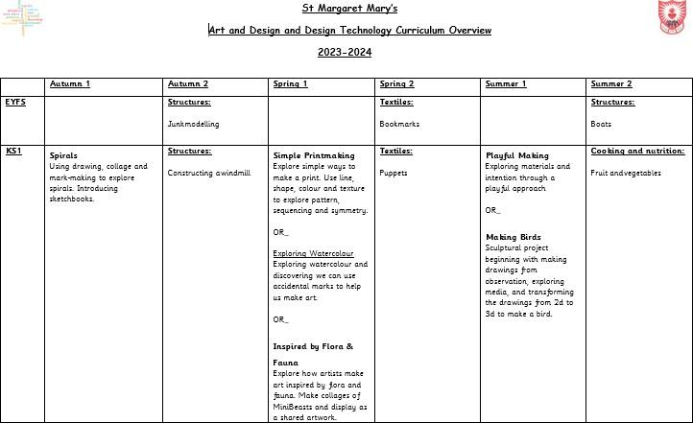

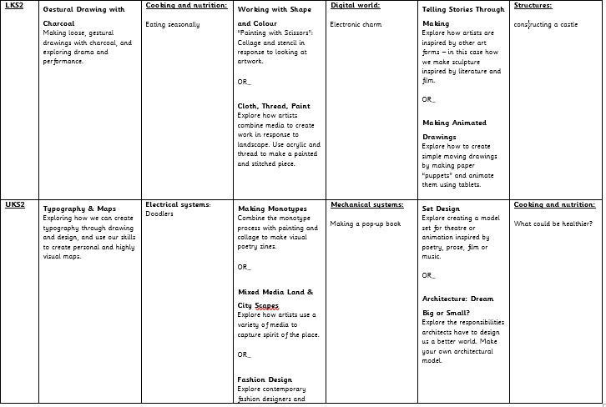

St Margaret Mary’s
Skill Progression in Design and Technology

Educational Programme
The development of children’s artistic and cultural awareness supports their imagination and creativity. It is important that children have regular opportunities to engage with the arts, enabling them to explore and play with a wide range of media and materials. The quality and variety of what children see, hear and participate in is crucial for developing their understanding, self-expression, vocabulary and ability to communicate through the arts. The frequency, repetition and depth of their experiences are fundamental to their progress in interpreting and appreciating what they hear, respond to and observe.
ELG 16 – Creating with Materials | ELG 17 – Being Imaginative
- Safely use and explore a variety of materials, tools and techniques, experimenting with colour, design, texture, form and function;  - Share their creations, explaining the process they have used;  - Make use of props and materials when role-playing characters in narratives and stories. | - Invent, adapt and recount narratives and stories with peers and their teacher;  - Sing a range of well-known nursery rhymes and songs;  - Perform songs, rhymes, poems and stories with others, and – when appropriate – move in time with music
Purpose
Design and technology is an inspiring, rigorous and practical subject. Using creativity and imagination, pupils design and make products that solve real and relevant problems within a variety of contexts, considering their own and others’ needs, wants and values. They acquire a broad range of subject knowledge and draw on disciplines such as mathematics, science, engineering, computing and art. Pupils learn how to take risks, becoming resourceful, innovative, enterprising and capable citizens. Through the evaluation of past and present design and technology, they develop a critical understanding of its impact on daily life and the wider world. High-quality
design and technology education makes an essential contribution to the creativity, culture, wealth and well-being of the nation.
KS1  Pupils should be taught to:  Design  - design purposeful, functional, appealing products for themselves and other users based on design criteria  - generate, develop, model and communicate their ideas through talking, drawing, templates, mock-ups and, where appropriate, information and communication technology  Make  - select from and use a range of tools and equipment to perform practical tasks [for example, cutting, shaping, joining and finishing] | KS2  Pupils should be taught:  Design  - use research and develop design criteria to inform the design of innovative, functional, appealing products that are fit for purpose, aimed at particular individuals or groups  - generate, develop, model and communicate their ideas through discussion, annotated sketches, cross-sectional and exploded diagrams, prototypes, pattern pieces and computer-aided design  Make

- select from and use a wide range of materials and components, including construction materials, textiles and ingredients, according to their characteristics  Evaluate  - explore and evaluate a range of existing products  - evaluate their ideas and products against design criteria Technical knowledge  - build structures, exploring how they can be made stronger, stiffer and more stable  - explore and use mechanisms [for example, levers, sliders, wheels and axles], in their products. | - select from and use a wider range of tools and equipment to perform practical tasks [for example, cutting, shaping, joining and finishing], accurately  - select from and use a wider range of materials and components, including construction materials, textiles and ingredients, according to their functional properties and aesthetic qualities  Evaluate  - investigate and analyse a range of existing products  - evaluate their ideas and products against their own design criteria and consider the views of others to improve their work  - understand how key events and individuals in design and technology have helped shape the world  Technical knowledge  - apply their understanding of how to strengthen, stiffen and reinforce more complex structures  - understand and use mechanical systems in their products [for example, gears, pulleys, cams, levers and linkages]  - understand and use electrical systems in their products [for example, series circuits  - incorporating switches, bulbs, buzzers and motors]  - apply their understanding of computing to program, monitor and control their products.

 | Pre-school | Nursery | Reception
Collage | - Begins to use different types of glue (PVA /glue stick) to stick a range of media and materials to stick things down to make their intended creation. Modelled and supported to meet individual need. | - Use glue sticks and spatulas with support  - Use glue sticks and glue spatulas independently (NR)  - Adds other materials to develop models (tissue paper, glitter…)  Additional textures – children describe as smooth or bumpy  - Explore different materials freely, in order to develop their ideas about how to use them  and what to make (3-4) | - Join items with glue or tape  - Join items in a variety of ways  – Sellotape, masking tape, string, ribbon  - Knows how to improve models (scrunch, twist, fold, bend, roll)  - Knows how to secure boxes, toilet rolls, decorate bottles  - Weave (fine motor) | -Beginning to cut, roll and coil materials for a purpose

Sculpture | - Uses 3D and 2D structures to explore materials and/or to express ideas  - Plays with a variety of construction toys, exploring how to build, join and connect  - Manipulates a variety of malleable materials and tools | - Builds towers by stacking objects  - Uses various construction materials, e.g. joining pieces, stacking vertically and horizontally, balancing, making enclosures and creating spaces  - Builds simple models using walls, roofs and towers. (NR)  - Makes marks in clay  - Manipulates clay (rolls, cuts, squashes, pinches, twists…)  - Uses tools for a purpose | - Builds models which replicate those in real life. Can use a variety of resources – loose part play  - Makes something that they give meaning to  - Makes something with clear intentions  - Uses malleable to create a representation or idea | -Can make a simple plan before making  -Beginning to cut, roll and coil materials for a purpose  -Beginning to make a product that moves  -Begining to understand how to make their model stronger
Independence | - Will explore a range of materials and resources to use for an intended purpose. | - Choose a piece of paper from a selection of 2/3 colours  - Chooses paper from a wide selection and of which is appropriate to the task (black paint on white paper, white paint on black…) (NR)  - Creates their own piece of art  - Creates their own piece of art and gives meaning  - Creates their own piece of art and begins to self-correct any mistakes (NR)  - Children work independently to develop basic skills  - Works with a friend, copying ideas and developing skills together | - Begins to paint on other materials – card, fabric, clay  - Returns to work on another occasion to edit and improve  - Creates collaboratively, sharing ideas with peers and developing skills further  - Expresses and communicates working theories, feelings and understandings using a range of art forms, e.g. movement, dance, drama, music and visual arts  - Chooses particular movements, instruments/sounds colours and materials for their own imaginative purposes | -Can make a simple plan before making  -Beginning to cut, roll and coil materials for a purpose  -Beginning to make a product that moves  -Begining to understand how to make their model stronger
Tools and  equipment (FM) | - Build independently with a range of appropriate resources  - Explore different materials and tools | - Use one handed tools and equipment to support fine motor movement. Tools include paintbrushes, hairbrushes, toothbrush, scarves, ribbons, scissors. | - Handles tools, objects, construction and malleable materials safely and with increasing control and intention.  - Selects appropriate tools and equipment for a purpose, e.g.  selects a pencil to draw a | - Handles tools, objects, construction and malleable materials safely and with confidence.  - Can demonstrate the safe use of tools to others

picture.
- Uses simple tools to effect changes to materials.
 | KS1 (Years 1 and 2) |  | LKS2 (Year 3 and 4) |  | UKS2 (Years 5 and 6)
Design | - Use my own ideas to make something.  - Explain how I want to make my product  - Choose appropriate resources and tools.  - Make a simple plan before making  - Describe how something works  - explore pictures/models focusing on features and how they have been made  - begin to develop ideas through talk and drawings  - design by drawing a picture and begin to label with materials that you will use.  - explain why materials are chosen.  - explain verbally to a friend what they are going to make.  - design by drawing a picture and label how you will join.  - Think of an idea and plan what to do next.  - Choose tools and materials and explain why I have chosen them.  - explore products to see how they have been made and how this can be used to make own design.  - explore joining techniques such as slits, folds, flaps.  - create a detailed design by drawing a picture and labelling the materials and tools that you will use and how they will be joined.  - make templates and mock ups of ideas in card or paper  - explain why materials are chosen by annotating.  - explain verbally in greater depth what they are making.  - discuss design with a friend and answer any  questions about it |  | - Design a product and make sure that it looks attractive.  - Follow a step-by-step plan, choosing the right equipment and materials.  - start to generate ideas for an item, considering its purpose and the user/s.  - start to order the main stages of making a product and establish criteria for a successful product.  - Use ideas from other people when I am designing.  - Produce a plan and explain it  - start to generate ideas, considering the purposes for which they are designing.  - confidently make labelled drawings from different views showing specific features.  - develop a clear idea of what has to be done, planning how to use equipment, materials and processes. |  | - Come up with different ideas after collecting information from different sources.  - Produce a detailed step-by-step plan.  - Suggest alternative plans  - Explain how a product will appeal to a specific audience,  - begin to generate, develop, model and communicate their ideas through discussion, annotated sketches, cross-sectional and exploded diagrams, prototypes, pattern pieces  - Show an understanding of the qualities if materials to choose appropriate tools.  - Follow and refine my plans  - Show that I consider culture and society in my plans and designs  - Use market research to inform plans and ideas generate, develop, model and communicate their ideas through discussion, annotated sketches, cross- sectional and exploded diagrams, prototypes, pattern pieces and computer-aided design.
Textiles | - develop sewing techniques using a range of different materials (before using needle and thread) such as card and hole punching, plastic weaving materials.  - use a prepared template.  - use a template to cut out fabric to make design.  - join fabrics by using running stitch, glue, staples, over sewing.  - develop a product by adding decoration with buttons, beads, ribbons and sequins, by joining with a glue gun (supervised) or sewing where appropriate.  - explore ways to colour fabrics using a range of techniques e.g. fabric paints, printing, painting.  - design, make and use their own template.  - explore ways of making and using more than one template at a time. |  | - Choose a textile for both its’ suitability and appearance.  - Prove that my design meets set criteria  - start to measure, tape or pin, cut and join fabric with some accuracy.  - understand the need for a seam allowance. To join textiles with appropriate stitching.  - sew using a range of different stitches, to weave and knit.  - demonstrate how to measure, tape or pin, cut and join fabric with some accuracy.  - select the most appropriate techniques to decorate textiles |  | - create objects (such as a cushion) that employ a seam allowance.  - join textiles with a combination of stitching techniques (e.g. back stitch for seams and running stitch to attach decoration).  - use the qualities of materials to create suitable visual and tactile effects in the decoration of textiles (such as a soft decoration for comfort on a cushion).

- cut out shapes which have been created by drawing round a template onto the fabric.
- join fabrics in different ways using stitching and become more proficient in sewing techniques.
- develop a product by sewing on decoration such as buttons,
beads, sequins, braids, ribbons.
Materials | - fold, tear and cut paper and card  - roll paper to create tubes  - cut along lines, straight and curved  - curl paper  - use hole punch  - insert paper fasteners for card linkages  - use simple pop ups  - identify and use materials to join e.g. split pins, masking tape, treasury tags.  - explore moving mechanisms and design and make a moving picture with at least one moving mechanism (e.g. pop up)  - fold, tear and cut paper and card  - roll paper to create tubes  - cut along lines, straight and curved  - curl paper  - insert paper fasteners for card linkages  - create hinges  - investigate strengthening sheet materials  - investigate and use joining techniques temporary, fixed and moving – slits, folds, flaps.  - explore, design and make a moving picture which uses a  combination of slider, levers and wheel mechanisms | - cut materials accurately and safely by selecting appropriate tools.  - select appropriate joining techniques.  - measure and mark out to the nearest mm.  - apply appropriate cutting and shaping techniques that include cuts within the perimeter of the material (such as slots or cut outs).  - measure and mark out to the nearest mm.  - apply appropriate cutting and shaping techniques that include cuts within the perimeter of the material (such as slots or cut outs). | - cut materials with precision and refine the finish with appropriate tools (such as sanding wood after cutting or a more precise scissor cut after roughly cutting out a shape).  - show an understanding of the qualities of materials to choose appropriate tools to cut and shape (e.g. the nature of fabric may require sharper scissors than would be used to cut paper).
Construction | - Cut materials safely, using the tools provided.  - Make a product which moves  - Make my model stronger  - begin to build structures, exploring how they can be made stronger, stiffer and more stable.  - make vehicles with construction kits which contain free running wheels  - use a range of materials to create models with levers and sliders  - join appropriately for different materials and situations e.g. glue, tape, mark out materials to be cut using a template To see a glue gun used by an adult  - Measure materials to use in a model or structure.  - Use different cutting, shaping techniques.  - Join materials and components in different ways.  - build structures, exploring how they can be made stronger, stiffer and more stable.  - make vehicles with construction kits which contain free running wheels | - Work accurately to measure, make cuts and make holes Select the most appropriate tools for a given task  - Make a product which uses both electrical and mechanical  components. | - Cut with precision  - Use a range of tools competently  - Make a prototype before a final version  Electricals and electronics:  - Create circuits using electronics kits that employ a number of components (such as LEDs, resistors, transistors and chips).  Computing:  - Write code to control and monitor models or products.  Construction:  - Develop a range of practical skills to create products (e.g cutting, drilling and screwing, nailing, gluing, filling and sanding).  Mechanics:  - Convert rotary motion to linear using cams.  - Work within a budget  - Ensure products have a high quality finish.  - Create circuits using electronics kits that employ a number of components with increasing confidence.
 |  | Electricals and electronics:
- Create series circuits.
- Control and monitor models using software designed for this purpose.
Construction:
- Choose suitable techniques to construct products or to repair items.
Mechanics:
- Use scientific knowledge of the transference of forces to choose appropriate mechanisms for a product (such as levers, winding mechanisms, pulleys and gears).
- Measure and cut accurately
- Apply appropriate cutting and shaping techniques.
 |  | Electricals and electronics:
 |  | - Create parallel circuits.

 | - use a range of materials to create models with wheels and axles e.g. tubes, dowel, cotton reels. To attach wheels to a chassis using an axle  - join appropriately for different materials and situations e.g. glue, tape,  - mark out materials to be cut using a template | Computing:  - Control and monitor models using software designed for this purpose.  Construction:  - Strengthen materials using suitable techniques.  Mechanics:  - Use scientific knowledge to choose appropriate mechanisms for a product. | Computing:  - Write code to control and monitor models or products  - Develop a range of practical skills to create products.  Mechanics:  - Use innovative combinations of electronics (or computing) and mechanics in product designs
Evaluate | - share product made with class and to say what went well and what could be done better/ differently next time.  - Explain what went well with my work  - evaluate their products and ideas against design criteria  - identify strengths and possible changes they might make to improve their products.  - talk confidently about their ideas, saying what they like and dislike. | - Explain how I have improved my original design  - Present a product in an interesting way  - Persevere and adapt my work when my original ideas do not work.  - Evaluate and suggest improvements for my designs.  - Evaluate products for both their purpose and appearance. | - Evaluate the appearance and function of a product against original criteria.  - evaluate different products  - create my own design criteria.  - evaluate my own work against design criteria.  - respond to the feedback of others.  - investigate designers and how they have had an impact Show that I can test and evaluate my products, against clear criteria.  - create my own design criteria.  - evaluate my own work against design criteria.  - respond to the feedback of others.  - investigate designers and how they have had an impact.
Cooking and  Nutrition | - Cut food safely  - develop a food vocabulary using taste, smell, texture and feel  - begin to group familiar food products e.g. fruit and vegetables into the five food groups (The Eat Well Plate)  - know how to use techniques such as cut, peel, grate, chop a range of ingredients  - know how to prepare simple dishes safely and hygienically, without using a heat source  - understand the need for a variety of foods in a diet To measure and weigh food items, non-statutory measures e.g. spoons, cups  - begin to understand that all food comes from plants or animals  - explore where food comes from (food has to be farmed, grown elsewhere (e.g. home) or caught)  - Measure, weigh using measuring cups or electronic scales.  - Describe the ingredients I am using.  - use a food vocabulary using taste, smell, texture and feel  - group familiar food products e.g. fruit and vegetables  - demonstrate how to cut, peel, grate, chop a range of ingredients  - prepare simple dishes safely and hygienically, without using a heat source  - understand the need for a variety of foods in a diet  - measure and weigh food items, non-statutory measures e.g. spoons, cups | - Describe how food ingredients come together.  - prepare ingredients hygienically using appropriate utensils.  - measure accurately.  - follow a simple recipe.  - begin to use techniques such as slicing, mixing, spreading, kneading and baking to assemble or cook ingredients.  - Know how to be hygienic and safe when using food.  - prepare ingredients hygienically using appropriate utensils.  - measure ingredients to the nearest gram.  - follow a recipe  - know how to use techniques such as slicing, mixing, spreading, kneading and baking to assemble and cook ingredients | - Show that I can be both hygienic and safe in the kitchen  - understand the importance of correct storage and handling of ingredients (knowledge of micro-organisms).  - demonstrate a range of baking and cooking techniques of predominantly savoury dishes.  - Demonstrate a range of baking and cooking techniques.  - measure accurately and calculate ratios of ingredients to scale up or down from recipe.  - create and refine recipes, including ingredients, methods,  cooking times and temperatures.

- understand that all food comes from plants or animals
- know that food has to be farmed, grown elsewhere (e.g. home) or caught

What DT looks like at St Margaret Mary’s
What an DT lesson looks like at our school: Planning:
Termly plans and resources are found and downloaded from the ‘Kapow’ D&T website. Strands planned link to a topic if possible however all year groups across the school will learn about the same strand of DT in the same term e.g EYFS – Year 6 will learn cooking skills in Summer 2. These plans are then forwarded to staff to amend if necessary. Planning is age appropriate and based upon prior skill set and learning.

Teaching:
Teachers are advised to make time for at least 3-4 sessions to complete product research, design, construct and evaluation. Resources and teaching plans are provided by subject leaders and differentiated relevant to their Key Stage.

Displays:
The D&T display is a collective celebration of work from all year groups showing the progression of skills from a particular strand e.g Textiles. This is then supported with evidence taken from sketchbooks of how the child has produced their final product and an evaluation that is differentiated to their year group.

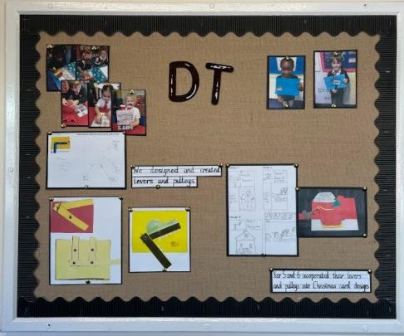

Assessment:
Class teachers are asked to complete a termly document where they individually assess children against ARE using the colour code red, yellow and green. This supports subject leaders to plan for future years and address gaps to ensure every child has covered all National Curriculum areas of D&T.

Inclusion:
DT is planned for according to the individual needs of the children – in line with the whole school policy surrounding equal opportunities and based upon our school aim to recognise that each child is unique. There are many ways in which SEND children can access the DT curriculum including:

- Ensuring familiarity with equipment
- The use of small steps during practical tasks
- Differentiated tasks that are adapted to meet the needs of pupils
- Additional adult support to ensure the development of skills
- Suitable resources that support learning and allow full participation
- The noise in design and technology lessons can be very uncomfortable for pupils with a hearing impairment. While a pupil is working on a practical activity allow them to switch off their aids if it is very noisy (remind them to switch them on again afterwards) e.g. blenders.
- Making tasks accessible for all pupils where appropriate by allowing use of specialist equipment e.g. specialist scissors and cutting tools and providing a range of drawing aids such as grids, templates and viewfinders for transcription.
- Preparing visual prompts by using images, photos or symbols to show the order in which to carry out a sequence of activities for a particular process.
- Some pupils will need to use nonvisual means to evaluate different products, to use this information to generate ideas and to become familiar with tools and other equipment. This will require extra time or support from an adult.
- Designing and making assignments that give pupils opportunities to work as individuals or in a team, learning from the work of others. For some pupils, e.g. those on the autistic spectrum, developing ideas with others can be challenging therefore pairings and groupings need to be sensitive to this.

Monitoring:
DT is monitored by the subject leaders throughout the year through the planning available on the shared drive and sketch book scrutinies to ensure that the progression document and LTP are followed. The consistent approach of planning from the skill progression document and the scrutinies of sketch books ensures coverage of all areas of the curriculum.

Parents:
Parents and carers are encouraged to attend and participate in school events such as interest in becoming art-ambassadors and the celebration of DT work completed both at home and in school through class displays and whole-school communal displays of DT work.

How do we know our children have made progress?
By the end of each key stage, pupils are expected to know, apply and understand the matters, skills and processes specified in the relevant programme of study in the skills progression document. Progress is clearly evident from the continuation of the use of sketchbooks across more than one academic year, allowing children, teachers and parents to clearly see the progress they are making across all areas.

