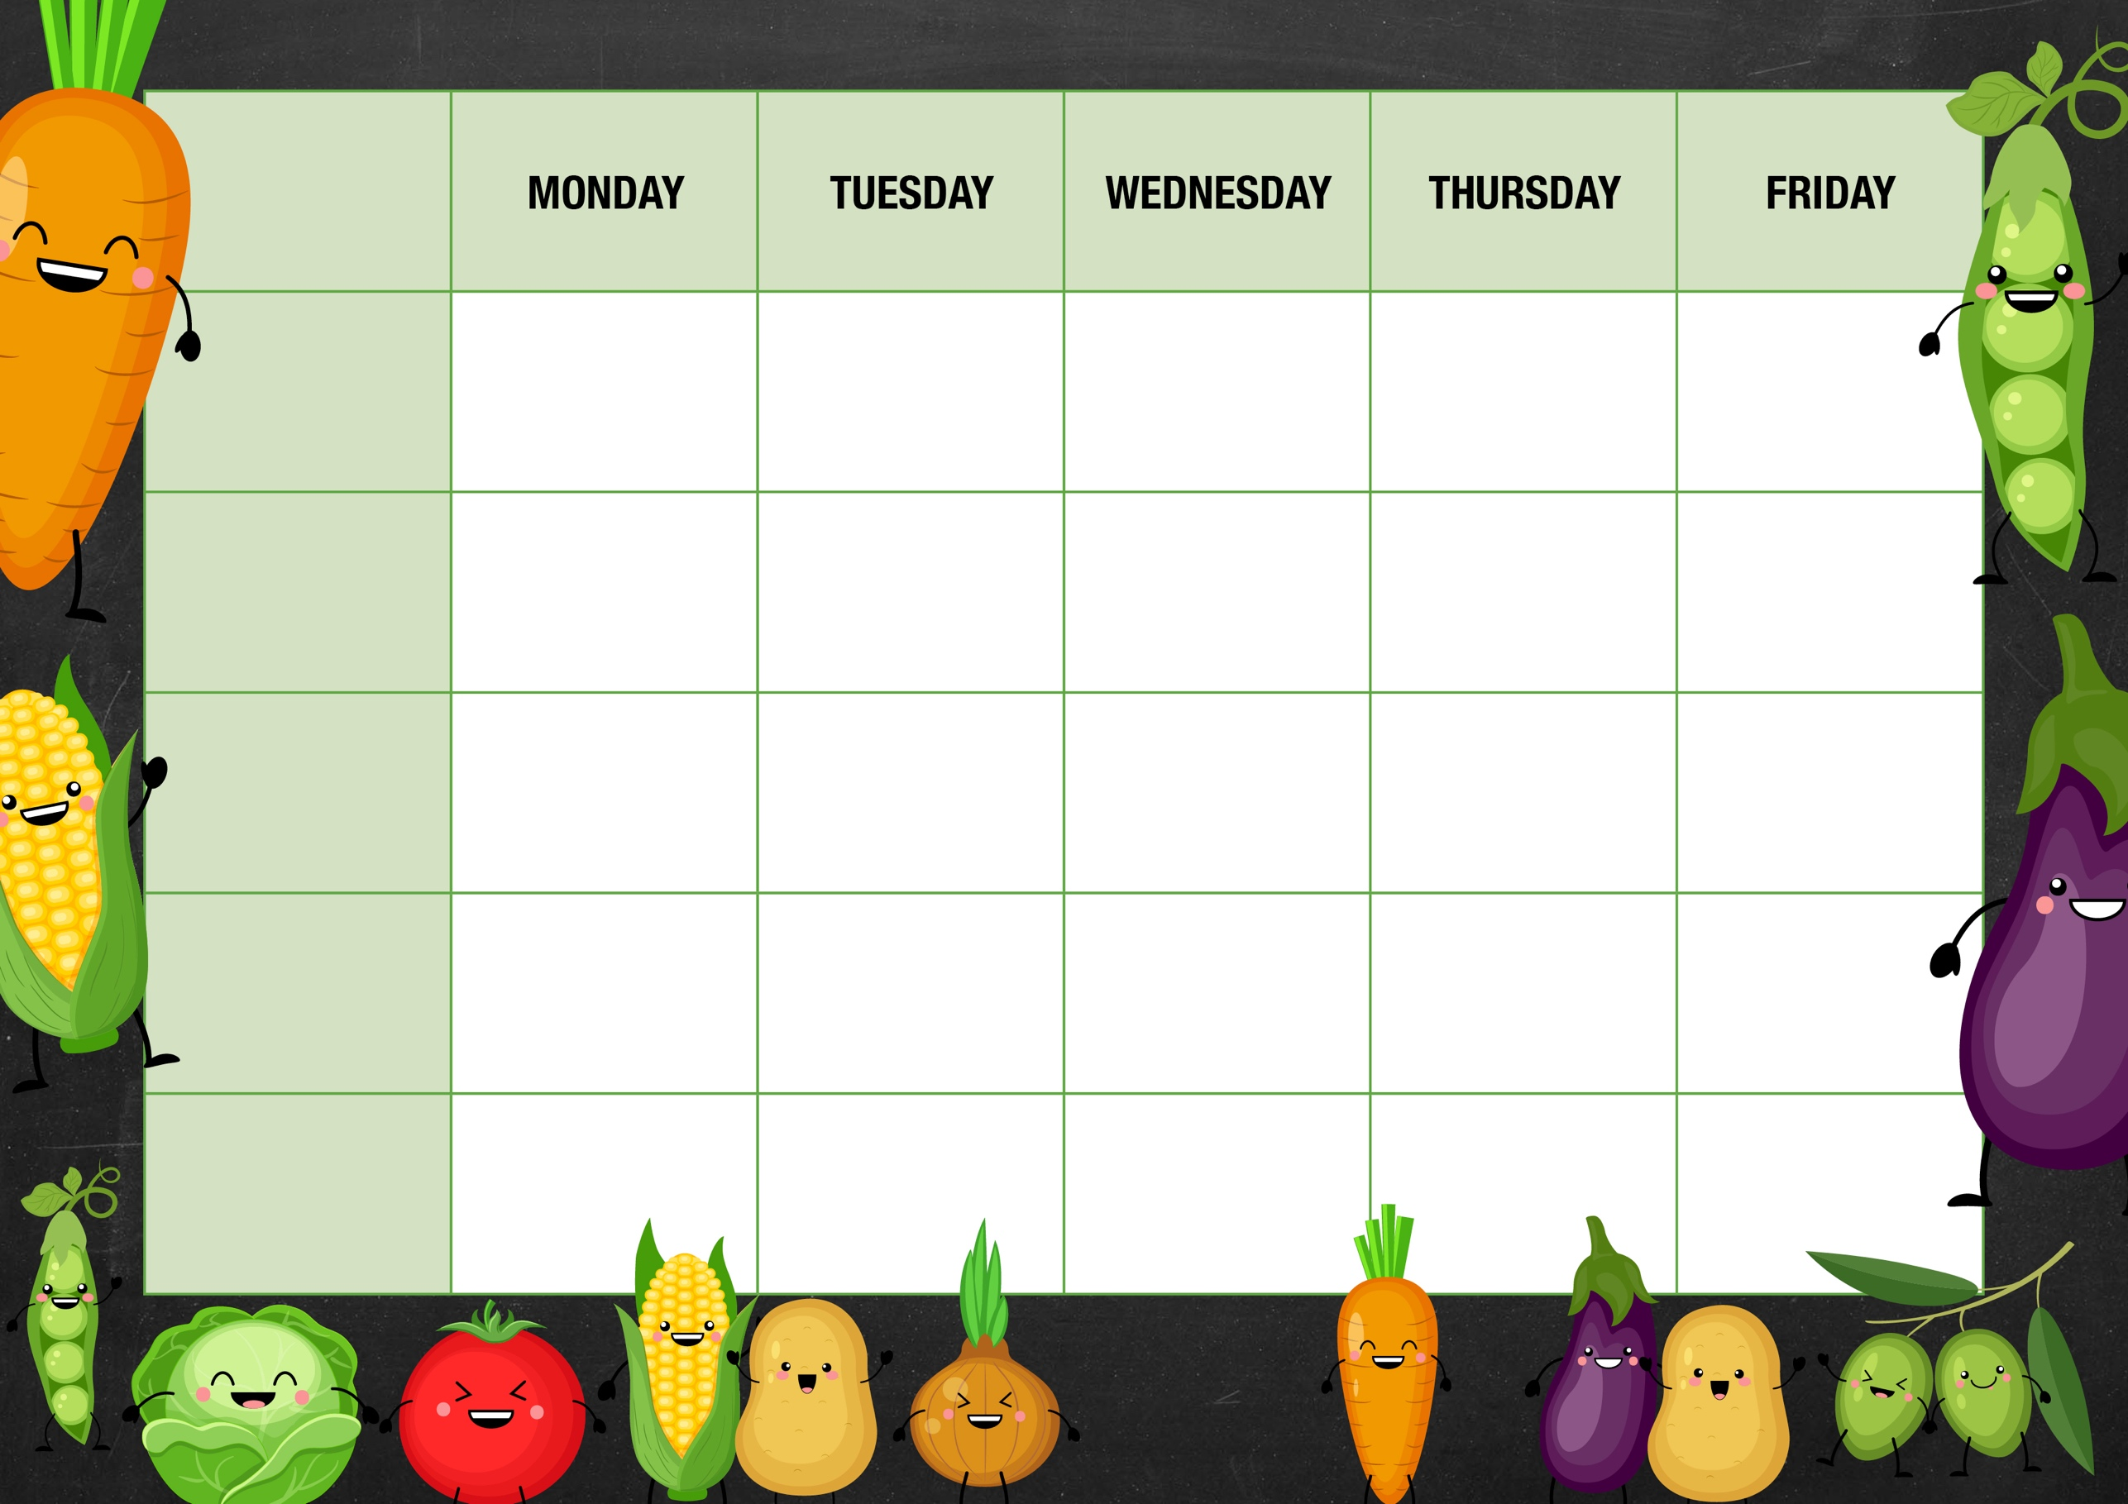

**Jacket Potato Bar**

* Beans
* Cheese
* Tuna Mayo
* Chefs special
* Beans
* Cheese
* Tuna Mayo
* Chefs special

Chicken Murgh Masala with coconut rice

Naan bread

**Week 2**

Ragu of Bolognese

Congiele Pasta

Garlic bread

Beef Casserole with warm baked bread

BBQ pulled pork and beans with Texan Rice

Smoked tomato and pepper pasta with creamy béchamel sauce and garlic bread

* Beans
* Cheese
* Tuna Mayo
* Chefs special
* Beans
* Cheese
* Tuna Mayo
* Chefs special
* Beans
* Cheese
* Tuna Mayo
* Chefs special

Did you know that potatoes were the first vegetable planted in space?

Did you know that broccoli contains more protein than steak?

Did you know that Honey is actually Bee sick? Forager bees regurgitate it back up!

Did you know that it was in fact a dentist that invented Candy Floss!

Did you know that fruit salad trees grow different fruits on the same tree at the same time?

Sandwich selection served with unlimited salad from our continental salad bar

Sandwich selection served with unlimited salad from our continental salad bar

Sandwich selection served with unlimited salad from our continental salad bar

Sandwich selection served with unlimited salad from our continental salad bar

Sandwich selection served with unlimited salad from our continental salad bar

Chefs selection of homemade desserts, biscuits, fresh locally sourced fruit and yoghurts

Chefs selection of homemade desserts, biscuits, fresh locally sourced fruit and yoghurts

Chefs selection of homemade desserts, biscuits, fresh locally sourced fruit and yoghurts

Chefs selection of homemade desserts, biscuits, fresh locally sourced fruit and yoghurts

Chefs selection of homemade desserts, biscuits, fresh locally sourced fruit and yoghurts

**Chefs Special**

**Fun Food Facts**

**The Deli**

**Chefs Pantry**