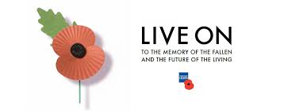
The commemoration of All Saints and the Holy Souls in November begins a month where the Church, in communion with all the saints, prays for the dead. For the bereaved, this month in particular, may mark some special time of remembrance.
In the spring of 1915, shortly after losing a friend in Ypres, a Canadian doctor, Lieutenant Colonel John McCrae was inspired by the sight of poppies growing in battle-scarred fields to write a now famous poem called 'In Flanders Fields'. After the First World War, the poppy was adopted as a symbol of Remembrance. We also see poppies as symbol of peace.
A hundred years after Battle of the Somme (1916) this November, each class has examined the Poppy as a Peace symbol and explored the work of artists using different media. The children have held Remembrance Assemblies, written and recited poetry, planted poppies in our Peace Garden, hung leaves on our Remembrance tree, visited our Prayer Room and have also researched, developed and refined work in their sketchbooks. We hope that you enjoy our work!
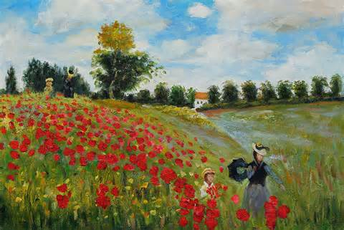
Monet Van Gogh Georgina O’Keefe
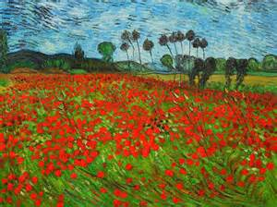 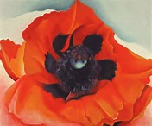
The French wear “le bluet, ” a blue cornflower, for remembrance and to link with anti-bullying week when we wore blue to Be Lovely and Understanding to Everyone, each child has also made a blue cornflower to help us promote mutual respect, tolerance, peace and understanding for all.
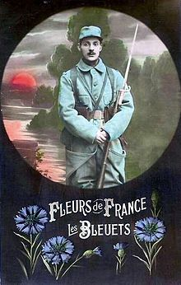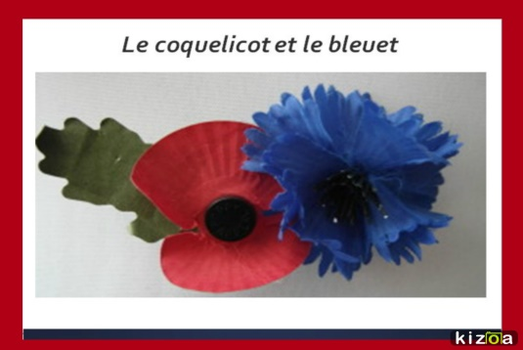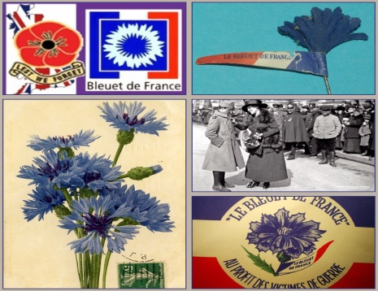
In the words of St Francis:
"Lord, make me an instrument of thy peace.
Where there is hatred, let me sow love;
Where there is injury, pardon;
Where there is doubt, faith;
Where there is despair, hope;
Where there is darkness, light;
Where there is sadness, joy……..
